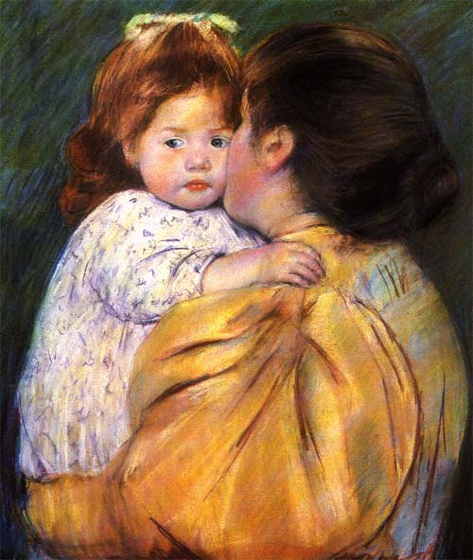

Cassatt, Mary: Maternal Kiss, 1896

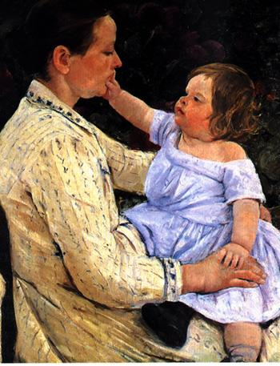

Cassatt, Mary : The Child’s Carress, 1891

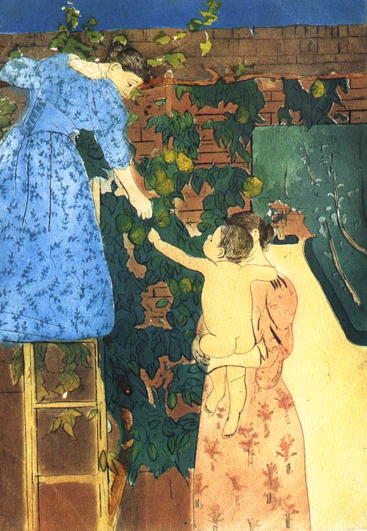

Cassatt, Mary: Gathering Fruit , 1895

